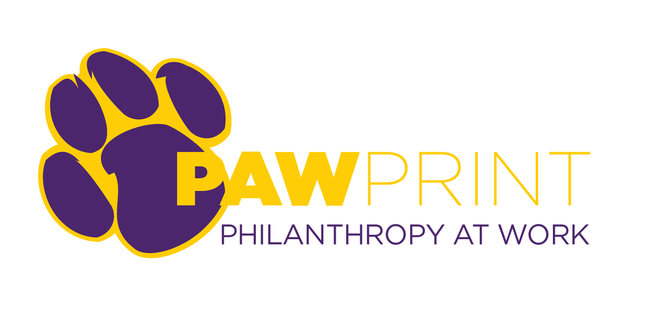
Resource Document for Student Organization Crowdfunding
Step 1: Reach out to the Office of Student Involvement (involvement@uni.edu) to meet with a Campus Programs Coordinator to schedule an introduction meeting.
- The Campus Programs Coordinator will talk through the initial stages of the planning process
Step 2: After approval from the Office of Student Involvement to move forward, fill out the PAWprint Application Form
- https://foundation.uni.edu/pawprint-campaign-application
Step 3: A meeting with the UNI Foundation Annual Giving Team will talk place to start talking through the logistics and timeline of a campaign
Step 4: With UNI Foundation approval, planning will begin
- Think through a project goal
- Build a case for support
- Provide photos
- Explore a challenge gift
- Build a social media/outreach plan

Project Timeline
The Quiet Phase (4-6 weeks prior to launch)
- Set up weekly meetings with Foundation annual giving staff
- Build a team and delegate duties
- Gather marketing materials (videos/photos, written content, social media, etc.)
- Form contacts and lists for outreach – the Foundation will put together a list of alumni that may be supportive of the project and student org should be building a list as well
Active Phase (4 weeks)
- Share fundraising links through social media, email, personal outreach
- Utilize a calendar to stay on track and have reoccurring outreach
- Thank donors and continue to post project updates (donor lists can be provided from Foundation staff)
- Implement and share stretch goal information if original goal is met
Post Campaign
- Steward donors who have given that you haven’t already thanked
- Share final updates with donors and on social media

Student Organization Expectations
- Obtain support from Office of Student Involvement
- Identify a team of organization members to lead the project
- Weekly meetings between organization leaders and Foundation staff
- An appropriate goal is identified and stretch goals are implemented if the goal is passed
- Compelling message and content is created to drive the project forward
- Explore a lead donor or challenge gift (ideally 10-25% of initial goal)
- An outreach strategy and calendar is created to keep the organization on track
- Project is launched for approximately 4 weeks or 30 days
- Outreach strategy is followed, goals are met, and everyone is happy
- A stewardship (thank you) plan is implemented to ensure supports know the impact of their gift and are encouraged to become yearly donors to UNI

How to Become an Advocate for Your Student Organization
Make an impact at your school by encouraging your classmates, family, and friends to support your student organization!
It’s easy. Here’s how:
✔️ Create a GiveCampus Account (or if you already have one, log in)
▹ We can only celebrate your hard work if we're able to tell it's you! And we do that by tracking outreach done when you're logged in to GiveCampus.
▹ Head to the Esports page at foundation.uni.edu/esports and click “SIGN UP”” or “LOGIN” at the top of the page.
▹ Create an account or login from there!

⭐️ Consider Your Own Gift and Offer a Match or Challenge
▹ Lead by example and make your own gift early. It's much easier to ask your friends and family to join you in making a gift when you’ve already done it yourself!
▹ Leverage your gift and encourage others to give by offering a match or challenge.
▹ Consider restricting your match or challenge by your designation you care about, class year, affiliation, or to a list of your friends (by email address) to raise the stakes

💌 Share, Share, Share
▹ The built-in sharing buttons on the campaign page generate a link that is unique to you. If you share while you're logged in, we can track it and celebrate your impact!
▹ Share via Facebook, Twitter, LinkedIn, Instagram, Text Message, Email, Phone Call, Carrier Pigeon… The sky’s the limit!

🎥 Tell Your Story
▹ Create a Personal Video and post it to the campaign page!
▹ Film a quick video in which you tell your community why you’re excited about the campaign, and why others should get involved. Keep it quick, casual, and fun!
Example Content Below

Esports Case for Support
About Panther Esports
Panther Esports is UNI’s official gaming organization for students. The organization is dedicated to creating a positive and friendly environment for all gamers, competitive and casual alike. They host a number of events each semester, including weekly tournaments, LAN tournaments, open houses and more!
Formed in 2016, Panther Esports has worked to provide as many opportunities as possible for its members. This includes securing a permanent open space to relax in between classes, covering and reimbursing competition fees to teams, and opening resume-growing positions under the Panther Esports executive board. Together, they hope to continue growing the opportunities presented to their members for many years to come!
Support Panther Esports
The Esports program is looking to raise $5,000 to upgrade needed equipment including TVs, PCs, monitors and other hardware and to purchase new games that have just been released. These upgrades will allow us to enhance the experience for our members and maintain Panther Esports as a hub for gamers on campus.

Email
Subject: Help Us Power Up Panther Esports!
Dear [Recipient's Name],
We are reaching out to invite you to support an exciting student group at the University of Northern Iowa — Panther Esports!
Founded in 2016, Panther Esports is UNI's official gaming organization, dedicated to creating a positive and welcoming space for all gamers, whether they play casually or competitively. Our organization hosts a variety of events each semester, including weekly tournaments, LAN tournaments and open houses. We also offer opportunities for students to get involved through leadership roles and resume-building experiences on our executive board.
As we continue to grow, we are raising $5,000 to upgrade essential equipment — such as TVs, PCs, monitors, and other hardware — and to purchase the latest games. These upgrades will allow us to enhance the experience for our members and maintain Panther Esports as a hub for gamers on campus.
[Insert Student Testimonial Section: Here, you can share your personal experience or how Panther Esports has impacted your time at UNI.]
By contributing to this organization, you’ll be investing in the future of Panther Esports and ensuring that we can keep providing incredible opportunities for gamers at UNI. Every gift, no matter the size, will make a huge difference.
Thank you for your support, and Go Panthers!
Warm regards,
[Your Name]
Panther Esports Team

Social Media
Post 1 (Twitter/X, Instagram, etc.):
🎮 Support Panther Esports! 🎮
We’re raising $5,000 to upgrade our gaming setup with new TVs, PCs, and the latest games. Every dollar helps us level up and keep creating amazing experiences for our members! 💻
Donate today ➡️ foundation.uni.edu/esports
#PantherEsports #1UNI #GamingCommunity
Post 2 (Facebook, LinkedIn, etc.):
Panther Esports is growing, and we need your help! We’re raising $5,000 to upgrade our equipment and purchase the latest games. Help us continue providing a positive and competitive space for gamers at UNI! 🎮💻
Donate today: foundation.uni.edu/esports
#PantherEsports #1UNI

